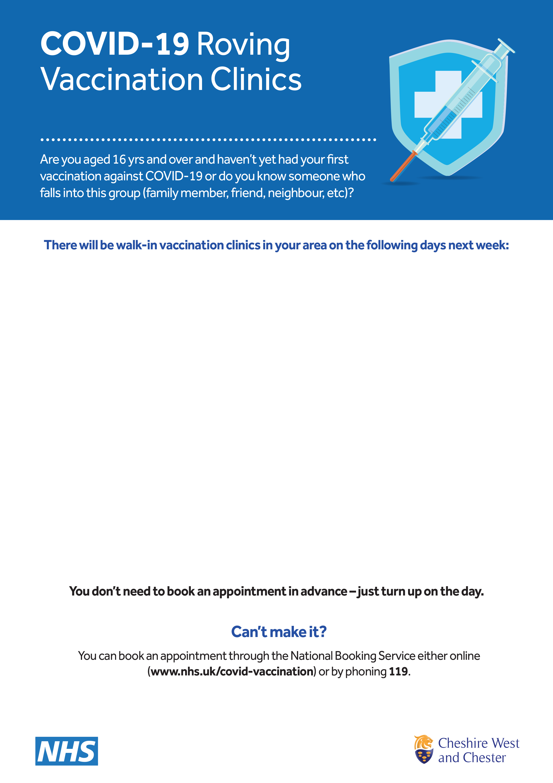

**Tarporley Community Centre**

13 December, 9am-6pm

14 December, noon-6pm

15 December, 9am-6pm

16 December, 9am-3pm

**Chester Cathedral**

15 December, 10am-5pm

16 December, 11am-6pm

17-21 December, 10am-5pm

**Bishop Heber High School**

18 and 19 December, 9am-6pm

Clinics will be offering both AstraZeneca and Pfizer vaccinations for **first** and **second** doses and Pfizer **booster** doses

Please note whilst we aim to be open until the displayed closing times, clinics may close early if demand has been high and all vaccine supply used on the day

**From Monday, 13 December, 2021**